**Website 1**

**Category**: online booking

**Name of website:** SiteMinder

**Link**: <https://www.siteminder.com/hotel-commerce/>

**Screenshot**:

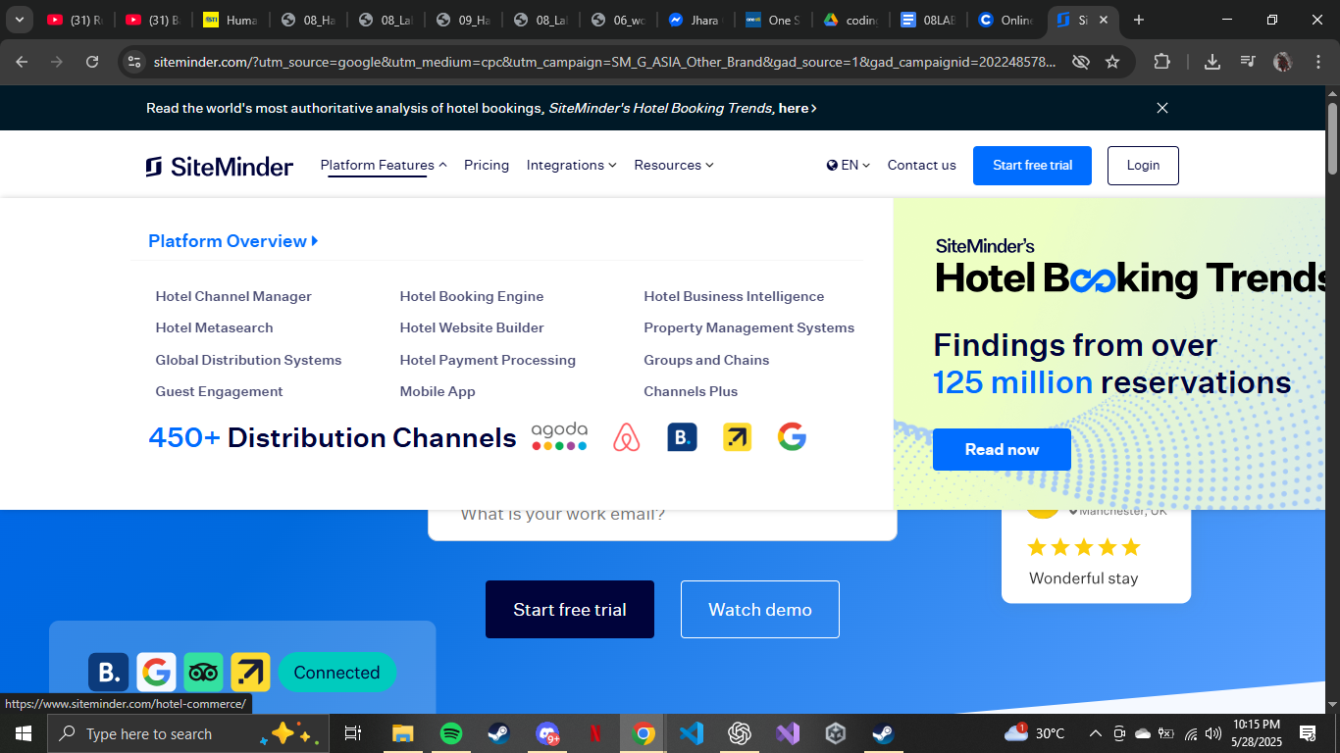

**Website 2**

**Category**: education

**Name of website**: Coursera

**Link**: <https://www.coursera.org/>

**Screenshot**:

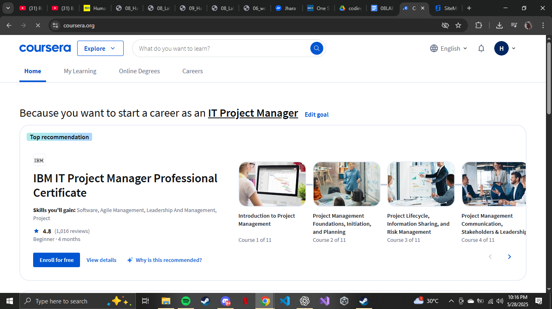

*What method would you use to evaluate the website or web application?*

In my understanding and knowledge, this is the best way. The best way to evaluate the user interface of a web application is to primarily focus on interviewing the user. It helps developers gather data to improve or fix an application during a beta or demo launch. After interviewing, the best course of action is to find out the answer to what to improve in measurement. Having a numerical score on the satisfaction of users' comprehension, satisfaction, and happiness with the User interface can greatly help determine if the progression of the application is good or bad.

| Ease of Use | 5/5 | Coursera is easy to use in the aspect of learning for beginners in the demographic os students or aspiring academics |
| --- | --- | --- |
| Learnability | 4/5 | I learned Coursera without outside help or looking at the manual or tutorial |
| Visual Design | 4/5 | The visual design of Coursera is minimalistic. Clean and efficient to use. |
| Content Clarity | 4/5 | Coursera’s Content clarity is simple and easy to understand due to its labeling system and specification of fields, and lastly, its detailed description per course. |
| Functionality | 5/5 | All content and buttons are functional and efficient to click |
| Overall Usefulness | 5/5 | Coursera is the best way to learn in any field no matter in business, Technology and etc. |